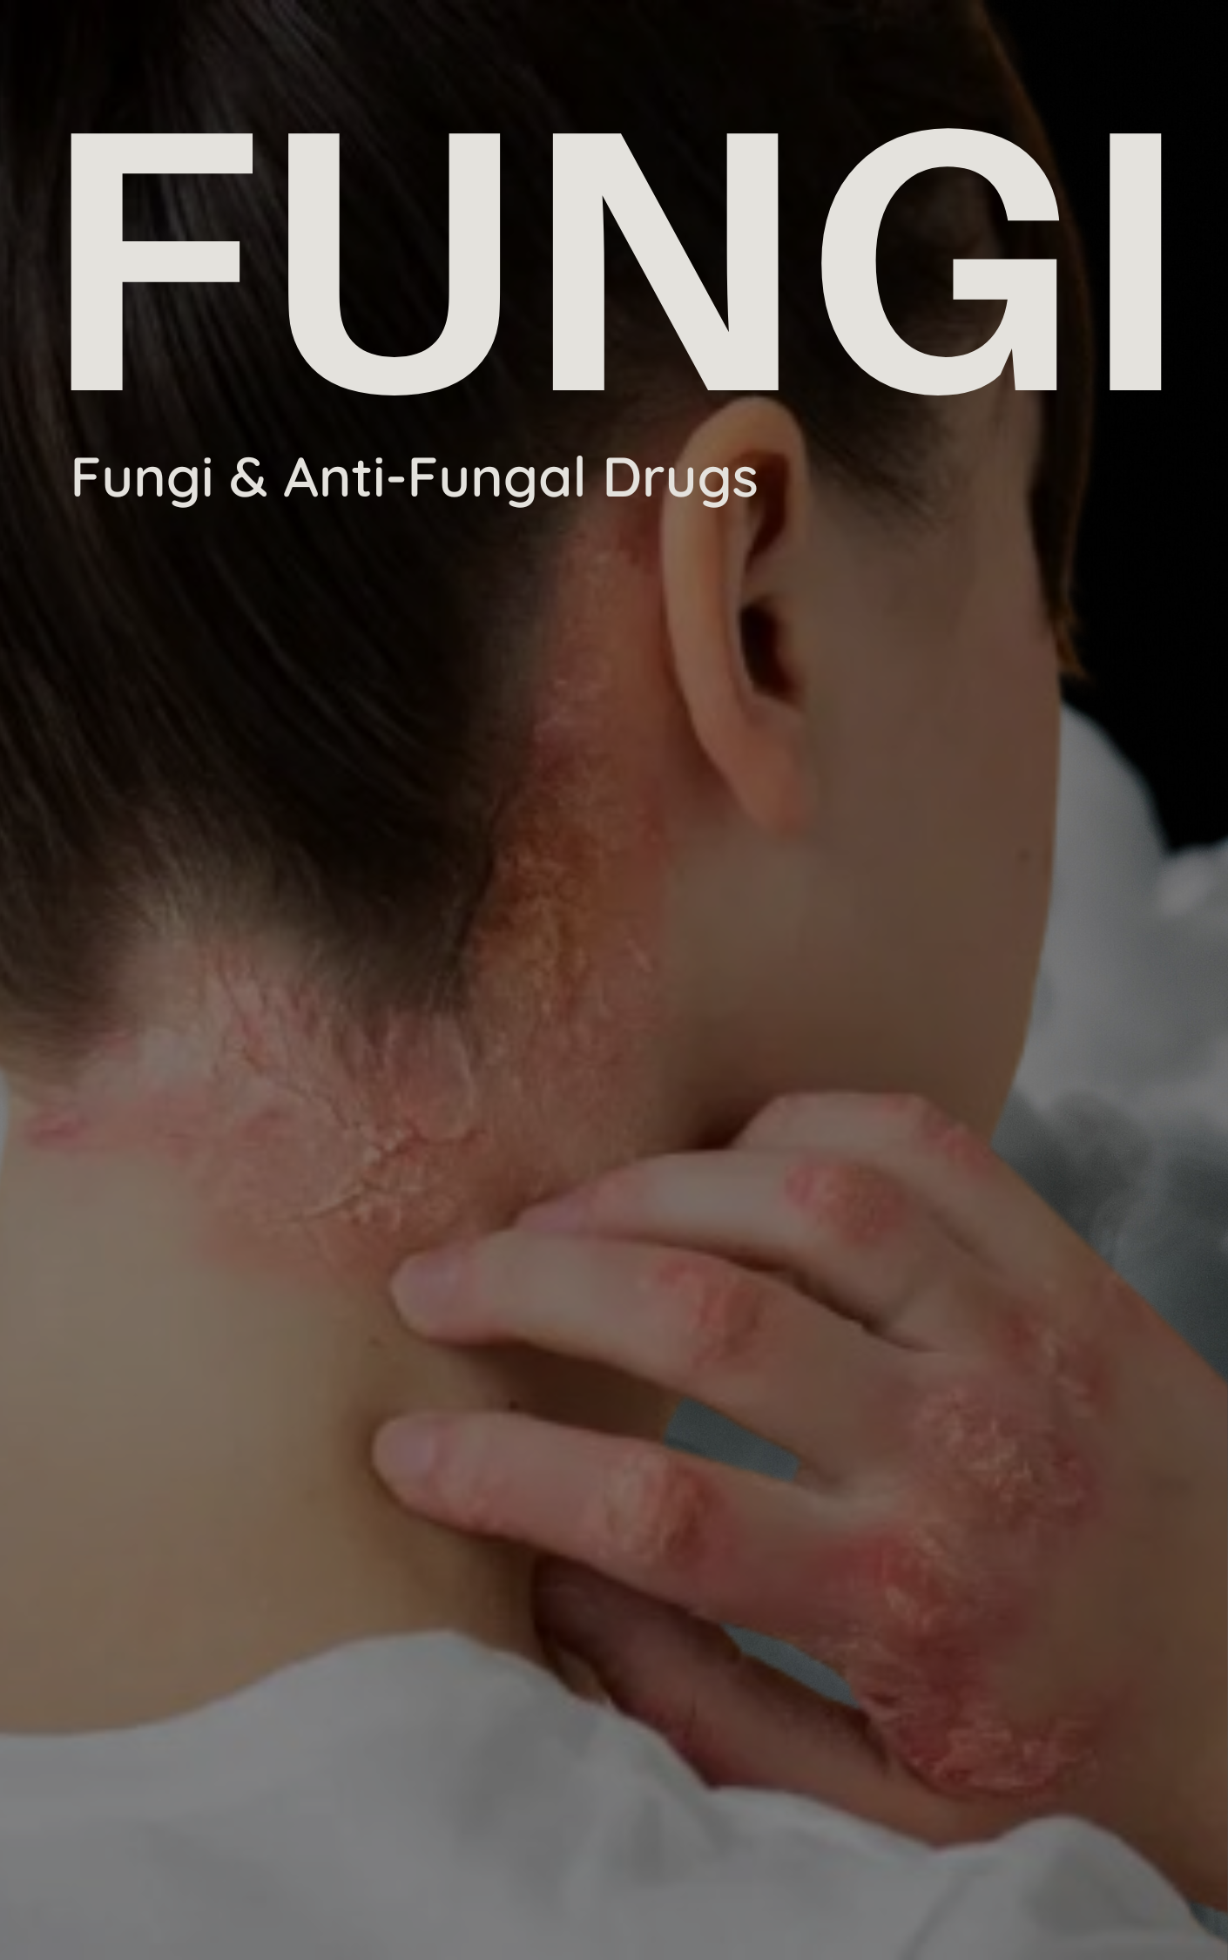

Table of Contents
Fungal Diseases (Mycoses) 3
Types of Fungal Diseases 3
Skin and Superficial Infections (Dermatomycoses) 3
• Ringworm (Tinea) 3
• Candida Infections 3
• Nail Fungal Infections (Onychomycosis) 3
Systemic Mycoses (Serious Infections) 3
• Aspergillosis 3
o Pulmonary Aspergillosis 3
• Histoplasmosis 3
• Systemic Candidiasis 3
• Cryptococcal Meningitis 3
• Fungal Endocarditis 3
• Opportunistic Infections 4
Vulnerable Groups 4
Classification of Antifungal Drugs 4
Systemic Antifungal Drugs 4
Amphotericin B 4
Flucytosine (5-FC) 5
Azoles 5
Allylamines 6
Topical Antifungal Medications 7
• Nystatin 7
• Topical Azoles 7
• Topical Ketoconazole 7
• Terbinafine and Naftifine (Allylamines) 7
Echinocandins 7

Antifungal Drugs

Fungal Diseases (Mycoses)
Fungal diseases are a diverse group of infections caused by fungi, ranging from common superficial skin infections to serious systemic conditions. They are ubiquitous in nature, playing crucial roles as decomposers and even symbionts.

Types of Fungal Diseases
Fungal infections are classified based on their location and affected organ systems:

Skin and Superficial Infections (Dermatomycoses)
These are the most common and affect the skin, hair, nails, and mucous membranes.
Examples:
- Ringworm (Tinea): "A common fungal infection causing itchy rashes," affecting areas like the scalp (Tinea capitis), body (Tinea corporis), groin (Tinea cruris) and feet (Athlete's Foot/Tinea pedis).
- Candida Infections: Caused by the fungus Candida, often appearing in warm, moist areas like the mouth (oral thrush) or genitals (vaginal candidiasis).
- Nail Fungal Infections (Onychomycosis): Cause discoloration, thickening, and crumbling of nails.

Systemic Mycoses (Serious Infections)
These involve deeper tissues or organs, such as lungs, bones, heart valves, brain, and eyes and can be very dangerous.
Examples:

Aspergillosis
  - A lung infection, often affecting immunocompromised individuals.
  - Pulmonary Aspergillosis: Aspergillus fumigatus is the most common culprit. This condition affects people with lung diseases like cystic fibrosis or asthma.
  - Pulmonary aspergillosis presents with a range of symptoms, from mild shortness of breath to severe respiratory distress. Coughing up blood, chest pain, and fever can also occur.
- Histoplasmosis: Affects the lungs, potentially causing neurological problems in severe cases. Caused by Histoplasma capsulatum, a dimorphic fungus.
- Systemic Candidiasis: Candida spreading to internal organs, particularly in immunocompromised individuals.
- Cryptococcal Meningitis: Caused by Cryptococcus neoformans, found in soil with bird droppings. Transmitted via inhalation and can lead to severe neurological complications.
- Fungal Endocarditis (particularly of artificial valves): A serious condition affecting heart valves, often prosthetic valves, caused by species like Candida, Aspergillus, and Mucor.
  - Symptoms include fever, chills, fatigue, chest pain, shortness of breath, and even possible murmurs in the heart. Diagnosis is confirmed through blood tests, echocardiography, and tissue biopsies
- Opportunistic Infections: These occur when normally harmless fungi cause disease due to a compromised immune system (e.g., in patients with cancer or HIV/AIDS).
  - Example: Cryptococcosis affecting the lungs and brain in immunocompromised individuals.

Vulnerable Groups
Certain populations are more susceptible to systemic fungal infections:

- Older people
- Diabetics
- Pregnant women
- Burn wound victims

Antifungal Drugs
Antifungal drugs are categorized into naturally occurring antibiotics and synthetic drugs, further classified by their mode of administration (systemic or topical).

Classification of Antifungal Drugs
- Naturally Occurring Antifungal Antibiotics: Polyenes (e.g., Amphotericin B, Nystatin), Echinocandins.
- Synthetic Drugs: Azoles, Fluorinated pyrimidines (e.g., Flucytosine), Allylamines (e.g., Terbinafine), Griseofulvin.

Systemic Antifungal Drugs

Amphotericin B
- A potent polyene macrolide antibiotic produced by Streptomyces nodosus, crucial for life-threatening fungal infections. It is "amphipathic," having both water-loving and water-repelling parts, enabling targeted interaction with fungal cell membranes.
- Mechanism of Action: Binds strongly to ergosterol (a sterol unique to fungal cell membranes), forming pores that cause leakage of ions (K+ ions) and macromolecules, leading to fungal cell death.
- Formulation: Nearly insoluble in water, requiring colloidal suspensions for IV administration. Liposomal Amphotericin B (L-AMB) significantly improves solubility and reduces toxicity by minimizing interaction with mammalian cells. It is made from lecithin and other biodegradable phospholipids. But costly.
- Clinical Uses: Broad-spectrum activity against yeasts (Candida albicans, Cryptococcus neoformans), endemic mycoses (Histoplasma capsulatum, Blastomyces dermatitidis), and molds (Aspergillus fumigatus, Mucor species). Used for initial induction therapy in severe infections.
- Side Effects:
  - Immediate: Fever, chills, muscle spasms, vomiting, headache, hypotension during infusion.
  - Cumulative Toxicity: "Renal Damage: Amphotericin B is the most common cause of acute renal failure." Also causes anemia and liver abnormalities.

Flucytosine (5-FC)
- A synthetic fluorinated pyrimidine analog. Related to 5-FU used as anti-metabolite in chemotherapy.
- Mechanism of Action: Absorbed by fungal cells via cytosine permease, converted to 5-FU and other active metabolites that disrupt DNA and RNA synthesis.
- Key Features: Water-soluble, readily absorbed orally, and distributes widely (including CSF). Eliminated via kidneys (90%), requiring dosage adjustment for renal impairment (The dosage is 100 mg/kg/d in divided doses in patients with normal renal function.).
- Clinical Use: "Flucytosine's primary use is in combination therapy with other antifungal agents like [Amphotericin B]. rarely used as a standalone treatment due to its narrow spectrum of action, and the potential for rapid resistance development." It synergistically acts with amphotericin B.
- Adverse Effects: Bone marrow suppression (anemia, leukopenia, thrombocytopenia), liver enzyme abnormalities, and occasionally toxic entero-colitis.

Azoles
- A vital class of synthetic drugs including ketoconazole, itraconazole, fluconazole, voriconazole, and posaconazole.
- Mechanism of Action: "Azoles block enzymes (e.g., lanosterol 14α-demethylase) responsible for converting sterols like lanosterol to ergosterol." This disrupts fungal cell membrane function, leading to cell death. They have a broad spectrum of activity.
Ketoconazole (KTZ):
- Specific Applications: Effective for dermatophytosis (athlete's foot, ringworm) and monilial vaginitis (yeast infections). Historically used for systemic mycoses, but largely replaced by triazoles.
- Contraindications: Pregnancy and breastfeeding.
- Adverse Effects: KTZ inhibits androgen production... leading to gynecomastia, loss of hair, menstrual irregularities... and a drop in serum hydrocortisone levels." Also, mild hepatotoxicity.
- Drug Interactions: Reduced absorption with H2 blockers, PPIs, antacids. Induces KTZ metabolism with rifampin, phenobarbital, carbamazepine, and phenytoin. Inhibits CYP450 enzymes.
Fluconazole:
- Key Features: Water-soluble with excellent oral bioavailability (94%), unaffected by food or gastric pH. Achieves high concentrations in CSF, ocular fluids, and vaginal tissue.
- Clinical Applications: Preferred for "Cryptococcal meningitis and disseminated candidiasis due to its superior penetration into the central nervous system." Also used for oropharyngeal/esophageal candidiasis and tinea infections.
- Considerations: Dose adjustment for renal impairment. Hepatic toxicity reported, especially in HIV/AIDS patients. Contraindicated in pregnancy and lactation.
Itraconazole:
- Key Features: Broad spectrum activity, including some molds like Aspergillus and fluconazole-resistant Candida strains. Fungistatic. "It is considered the first-line azole antifungal for most systemic mycoses, excluding those associated with meningitis."
- Clinical Use: Effective against systemic mycoses (histoplasmosis, blastomycosis, sporotrichosis) and dermatophytosis, especially onychomycosis.
- Drug Interactions: Reduced absorption with antacids, H2 blockers, PPIs. Metabolism induced by rifampin, phenobarbitone, phenytoin, carbamazepine.
Voriconazole:
- A second-generation triazole with broad-spectrum activity.
  - Triazoles: A subclass of azoles with a three-nitrogen ring, making them more specific and often safer
- Clinical Use: Considered the first-line agent for invasive Aspergillus infections. Effective for invasive aspergillosis, disseminated candidiasis (including fluconazole-resistant strains).
- Route of Administration: Available in IV and oral forms. Oral absorption hindered by fatty meals.
- Side Effects: Rashes, visual disturbances, QT prolongation, potential anaphylaxis.
Posaconazole:
- "The most potent triazole available." Predominantly available as an oral suspension.
- Clinical Use: "Offers unique efficacy against mucormycosis, a particularly difficult fungal infection." Also used for salvage therapy of resistant aspergillosis and invasive candidiasis.
- Drug Interaction Profile: Similar to ketoconazole.
Allylamines:
Terbinafine:
- Synthetic allylamine fungicidal medication.
- Mechanism of Action: Inhibits fungal enzyme squalene epoxidase, disrupting ergosterol synthesis and causing squalene accumulation, which is toxic to fungal cells. "Unlike azole antifungal agents (which act primarily as fungistatic), terbinafine is directly fungicidal."
- Key Advantages: Fungicidal action, lipophilic and keratinophilic nature allowing concentration in skin and nails.
- Clinical Applications: Highly effective for onychomycosis (up to 90% cure rates) and various dermatophyte and Candida infections (ringworm, athlete's foot). Available for both oral and topical application.
- Side Effects: Generally well tolerated orally; GI upset, rash, headache. Rarely, hepatotoxicity. Topical application can cause erythema, itching, dryness, rashes.
Griseofulvin:
- An older oral systemic drug for mucocutaneous infections, largely replaced by newer agents.
- Mechanism of Action: Disrupts fungal mitosis by binding to microtubules and binds to keratin in skin cells, preventing new fungal infections. Requires extended treatment.
- Key Aspects: Narrow-spectrum, effective primarily against dermatophyte infections. Administered orally.
- Potential Drawbacks: "Limited Applicability," "Toxicity Concerns" (allergic reactions, skin issues, lupus-like syndrome, liver damage), and "Relapse Risk." "Griseofulvin has largely been replaced by newer and more effective antifungal medications like itraconazole and terbinafine."

Topical Antifungal Medications
Applied directly to affected areas, minimizing systemic effects and toxicity.
- Nystatin: A polyene macrolide antibiotic for local Candida infections like oral/vaginal thrush and intertriginous candidiasis. Safe with limited side effects.
- Topical Azoles: Clotrimazole and Miconazole are common. Effective against dermatophytes (tinea corporis, tinea cruris) and Candida species (vulvovaginal candidiasis, oral thrush). Clotrimazole is noted for its extended residual effect for vaginitis.
- Topical Ketoconazole: Available as cream and shampoo for seborrheic dermatitis.
- Terbinafine and Naftifine (Allylamines): Topical creams effective against tinea cruris and tinea corporis.

Echinocandins
- A new class of licensed antifungals specifically for invasive and systemic fungal infections, administered intravenously.
- Mechanism of Action: Interferes with β-glucan synthesis (a key component of the fungal cell wall), causing cell wall disruption and fungal cell death. Offers high specificity to fungal cells, minimizing human cell damage.
- Pharmacokinetic Profiles: All three (Caspofungin, Micafungin, Anidulafungin) are IV formulations with varying half-lives.
- Clinical Use:
  - Caspofungin: Used for mucocutaneous candidiasis, invasive aspergillosis, febrile neutropenia (especially as a replacement for amphotericin B).
  - Micafungin: Targets mucocutaneous candidiasis, and prophylaxis of candida infections in bone marrow transplant patients.
  - Anidulafungin: Approved for invasive and esophageal candidiasis (including candidemia).
- Toxicity: May cause gastrointestinal effects (nausea, vomiting) and renal impairment.

